## 结果截图

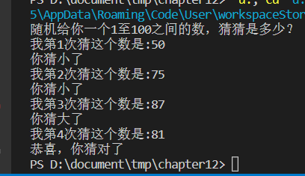

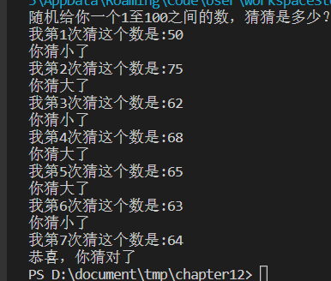

## 代码截图

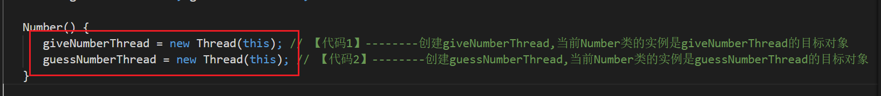

## 源码

public class TwoThreadGuessNumber {

public static void main(String args[]) {

Number number = new Number();

number.giveNumberThread.start();

number.guessNumberThread.start();

}

}

//

public class Number implements Runnable {

final int SMALLER = -1, LARGER = 1, SUCCESS = 8;

int realNumber, guessNumber, min = 0, max = 100, message = SMALLER;

boolean pleaseGuess = false, isGiveNumber = false;

Thread giveNumberThread, guessNumberThread;

Number() {

giveNumberThread = new Thread(this); // 【代码1】--------创建giveNumberThread,当前Number类的实例是giveNumberThread的目标对象

guessNumberThread = new Thread(this); // 【代码2】--------创建guessNumberThread,当前Number类的实例是guessNumberThread的目标对象

}

public void run() {

for (int count = 1; true; count++) {

setMessage(count);

if (message == SUCCESS)

return;

}

}

public synchronized void setMessage(int count) {

if (Thread.currentThread() == giveNumberThread && isGiveNumber == false) {

realNumber = (int) (Math.random() * 100) + 1;

System.out.println("随机给你一个1至100之间的数，猜猜是多少？");

isGiveNumber = true;

pleaseGuess = true;

}

if (Thread.currentThread() == giveNumberThread) {

while (pleaseGuess == true)

try {

wait(); // 让出CPU使用权，让另一个线程开始猜数

} catch (InterruptedException e) {

}

if (realNumber > guessNumber) { // 结束等待后，根据另一个线程的猜测给出提示

message = SMALLER;

System.out.println("你猜小了");

} else if (realNumber < guessNumber) {

message = LARGER;

System.out.println("你猜大了");

} else {

message = SUCCESS;

System.out.println("恭喜，你猜对了");

}

pleaseGuess = true;

}

if (Thread.currentThread() == guessNumberThread && isGiveNumber == true) {

while (pleaseGuess == false)

try {

wait(); // 让出CPU使用权，让另一个线程给出提示

} catch (InterruptedException e) {

}

if (message == SMALLER) {

min = guessNumber;

guessNumber = (min + max) / 2;

System.out.println("我第" + count + "次猜这个数是:" + guessNumber);

} else if (message == LARGER) {

max = guessNumber;

guessNumber = (min + max) / 2;

System.out.println("我第" + count + "次猜这个数是:" + guessNumber);

}

pleaseGuess = false;

}

notifyAll();

}

}